OVERVIEW TAB
Course Description:
The Department of Computer Science & Information Technology (CSIT) at KIET Group of Institutions was established in 2018. Our mission is to empower students to thrive in today’s fast-changing digital world. With NBA accreditation, the department offers a constantly updated curriculum designed by both academic and industry experts to meet real-world technological demands. Our focus is on developing problem-solvers, innovators, and future leaders, not just programmers. Choosing CSIT at KIET means selecting a program built for the future, supported by modern infrastructure and global exposure.
Key Highlights:
- Modern, well-equipped labs for RPA (Robotic Process Automation), Data Science, Machine Learning (ML), and other emerging fields
- Dedicated Centres of Excellence in Cyber Security (in collaboration with Wipro) and AWS (Amazon Web Services)
- Strong research culture with 100+ patents filed and 50+ research papers published
- Student achievements at platforms like ISB Hyderabad, TIE App-a-thon California, and IIT Hackathons
- Robust industry and academic collaborations for real-world exposure
- Consistent 100% placement record with top global recruiters
This blend of innovation, industry connections, research strength, and consistent placements ensures excellent career opportunities for our graduates while nurturing them into competent professionals ready for the global tech landscape.
Vision
To achieve preeminence in providing skill enabled technical education in the domain of Computer Science Engineering for producing competent professionals.
Mission
- To provide students with necessary skills and knowledge to meet current and future requirements using innovative teaching and learning approaches.
- To impart skill-based computer science and engineering education by adopting contemporary tools and technologies.
- To develop industry-academia alliance for practicing industry-oriented projects and internships to open new opportunities in industry, research, and entrepreneurship.
- To keep the intellectual capital of the department motivated for learning about technological changes by providing them with a conductive environment.
Program Outcomes
- Engineering knowledge: Apply the knowledge of mathematics, science, engineering fundamentals, and an engineering specialization to the solution of complex engineering problems.
- Problem analysis: Identify, formulate, review research literature, and analyze complex engineering problems reaching substantiated conclusions using first principles of mathematics, natural sciences, and engineering sciences.
- Design/development of solutions: Design solutions for complex engineering problems and design system components or processes that meet the specified needs with appropriate consideration for the public health and safety, and the cultural, societal, and environmental considerations.
- Conduct investigations of complex problems: Use research-based knowledge and research methods including design of experiments, analysis and interpretation of data, and synthesis of the information to provide valid conclusions.
- Modern tool usage: Create, select, and apply appropriate techniques, resources, and modern engineering and IT tools including prediction and modeling to complex engineering activities with an understanding of the limitations.
- The engineer and society: Apply reasoning informed by the contextual knowledge to assess societal, health, safety, legal and cultural issues and the consequent responsibilities relevant to the professional engineering practice.
- Environment and sustainability: Understand the impact of the professional engineering solutions in societal and environmental contexts, and demonstrate the knowledge of, and need for sustainable development.
- Ethics: Apply ethical principles and commit to professional ethics and responsibilities and norms of the engineering practice.
- Individual and team work: Function effectively as an individual, and as a member or leader in diverse teams, and in multidisciplinary settings.
- Communication: Communicate effectively on complex engineering activities with the engineering community and with society at large, such as being able to comprehend and write effective reports and design documentation, make effective presentations, and give and receive clear instructions.
- Project management and finance: Demonstrate knowledge and understanding of engineering and management principles and apply these to one's own work, as a member or leader in a team, to manage projects in multidisciplinary environments.
- Life-long learning: Recognize the need for, and have the preparation and ability to engage in independent and life-long learning in the broadest context of technological change.
NBA DATA - (PDF Attachment)
Dean’s message (TAB 2)
Faculty(TAB 3)
PROFESSOR | 2
ASSOCIATE PROFESSOR | 4
ASSISTANT PROFESSOR | 28
PROFESSOR OF PRACTICE
ADJUNCT FACULTY

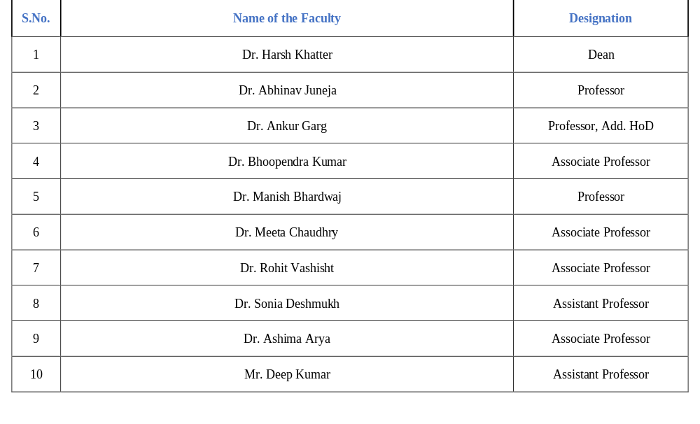

Publications & Research (TAB 4)
S.No | Year | Journals | Conferences | Books | Book Chapters | Patents Published | Patents Granted
1 | 2023-2024 | 5 | 5 | 2 | 9 | 4 | 3
2 | 2022-2023 | 19 | 18 | 1 | 3 | 24 | -
3 | 2021-2022 | 15 | 4 | 4 | 12 | 13 | -
Research Publications (Session 2023-2024)
Overall Research Summary
Publication Category | Count
Journal | 13
Conference | 25
Book | 03
Book Chapter | 06
Patent (Published) | 66
Patent (Granted) | 02
Ph.D Guidance | 10

Journal Publication (Sample for PDF file as shown below)
S.No. | Name of Faculty | Paper Title | Journal Name | Date of Publication | Indexing
1 | Ms. Garima Singh | Minimizing Energy Consumption in WSN-IoT Networks by  Focusing on Quality of Service | Journal of Computer Science | 13/08/2024 | SCOPUS
2. | Dr. Sonia Deshmukh | Mult objective Binary Differential Approach with Parameter Tuning for Discovering Business Process Models: MoD-ProM | The Scientific world Journal | 27/08/2024 | SCOPUS

Conference Publication (Sample for PDF as shown below)
S.No. | Name of Faculty | Paper Title | Conference Name | Date of Publication | Publisher & Indexing
1. | Ms. Arti Pandey | A Machine Learning based Depression Detection via Questionnaires and Video | 15th International Conference on Computing Communication and Networking Technologies (ICCCNT) 2024 | 11/04/2024 | IEEE  (SCOPUS)
2. | Dr. Rohit Vashisht | A Comprehensive Examination of Machine Learning Models in Predicting 16 Personality Traits | Proceedings of Fifth Doctoral Symposium on Computational Intelligence | 11/06/2024 | Springer (SCOPUS)
Book Publication (Sample for PDF as shown below)
S.No. | Name of Faculty | Book Title | Publisher Type | Date Of Publication
1. | Ms. Supriya Dubey | Cyber Security and Ethical Hacking | International | 18/07/2024
2. | Dr. Manish Bhardwaj | Crash Course on programming for Problem Solving | International | 30/11/2024
Book Chapter Publication (Sample for PDF as shown below)
S.No. | Name of Faculty | Book Title | Book Chapter Title | Publisher Type | Date of Publication | Indexing
1. | Dr. Rohit Vashisht & Ms. Garima Singh | A Handbook of Computational Intelligence: Artificial Intelligence in Natural Language Processing | A Comprehensive Study of Natural Language Processing | International | 01/08/2024 | WEB OF SCIENCE
2. | Dr. Manish Bhardwaj | Explainable Artificial Intelligence for Autonomous Vehicles- Concepts, Challenges, and Applications | Emerging applications and future scope of internet of vehicles for smart cities-A Survey | International | 13/08/2024 | SCOPUS
Patents Publication (All Patents have been published at National Level) (Sample for PDF as shown below)
S.No. | Name of Faculty | Patent Number | Patent title | Date of Publication
1. | Ms. Garima Singh & Dr. Meeta Chaudhry | 202421046676 | An IOT-Based, AI-Powered, And Machine Learning-Based School Security System | 19/07/2024
2. | Ms. Supriya Dubey & Dr. Manish Bhardwaj | 202411057736 | Design And Develop Innovative Technology for Managing Patient Data and Support Decision Making | 16/08/2024
Patents Granted (Sample for PDF as shown below)
S.No. | Name of Faculty | Patent Number | Patent title | Category | Date of Grant
1. | Dr. Ankur Garg & Mr. Vinay Kumar | 6387993 | Artificial Intelligence Based Heart Rate Monitoring Device | National | 24/09/2024
2. | Dr. Manish Bhardwaj | 449280-001 | Machine Learning based Infant Body Warmer Device | International | 15/05/2025

Ph.D Guidance (Sample for PDF as shown below)
S.No. | Name of Faculty | Name of Ph.D Scholar | Thesis Title | University Name
1. | Dr. Harsh Khatter | Ms. Neha Shukla | ECG Arrhythmia Abnormality Detection Using Machine Learning Algorithms | SRMIST Kattankulathur
2. | Dr. Harsh Khatter | Ms. Garima Panwar | Posture Identification | Amity University, Greater Noida
3. | Dr. Harsh Khatter | Mr. Puneet Kumar Goyal | Skin Lesion | NIU Greater Noida
ACHIEVEMENT (TAB 5)
- Student’s achievements with National accolades
- Name of the student, batch
- Description of 50 words
- High Quality Pictures

ACTIVITIES (TAB 6)
- Department activities
- Name of the activity
- Description of 50 words
- High Quality Pictures
INFRASTRUCTURE (TAB 7)
Class Room
We have well-equipped class rooms with smart touch boards, audio system and internet facilities.
Labs (1-2 Liners description required about the labs)
World-class laboratories offering hands-on experience in cutting-edge technologies like RPA, Data Science, Machine Learning, and Cloud Computing.
- Robotic Process Automation Lab:
- Data Structures and Algorithms Lab:
- Data Science and Machine Learning Lab:
- Computer Organization and Architecture Lab:
PLACEMENT (TAB 8)
Year | Highest Package | Average Package | Percentage of Placement
2024-2025
2023-2024

CoE (TAB 9)
- Name of the Centre of Excellence
- Description of 200 words

TESTIMONIAL (TAB 10)
- Student Name
- Batch
- Message from Alumni
- Formal Picture (High Quality)
CLUBS (TAB 11)
- Name of the club
- Logo of the club
- Description of Club in 100 words
SYLLABUS (TAB 12)
Please follow the below format for PDF:
- CSIT 1st Year
- CSIT 2nd Year
- CSIT 3rd Year
- CSIT 4th Year

